Assignment 2 - SELECT * from employees WHERE first_name like 'Y%n'  
  
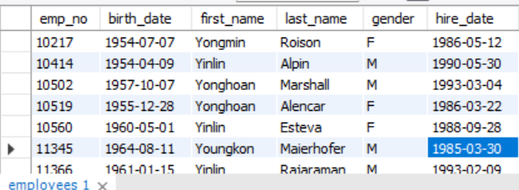  
  
  
Assignment 3 - SELECT emp_no, salary, (salary * 1.3) AS increased_salary FROM salaries  
  
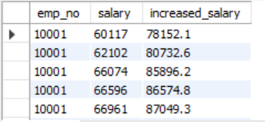  
  
Assignment 4 - SELECT DISTINCT title FROM titles  
  
